**NEW:**

1. In List all Branches, column ‘Branch Name’ should be in blue colour and show black arrow down when hovering over- like other columns.

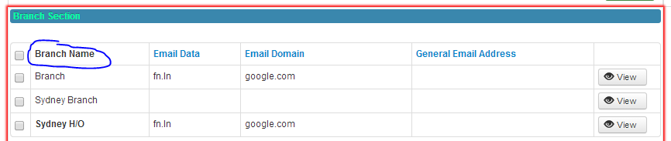

1. In ‘List all Offices’, columns ‘Postal Address’ and ‘Street Address’ should appear in blue and show black arrow down when hovering over- like other columns.

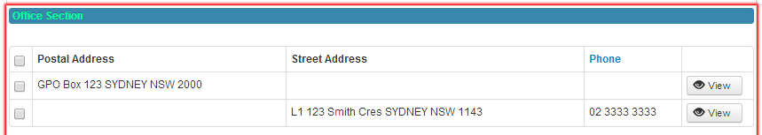

1. In ‘List all Positions’, columns ‘First Name’, ‘Last Name’, ‘Full Job Title’, ‘Suppression’, ‘Updated’ should appear in blue and show black arrow down when hovering over- like other columns.

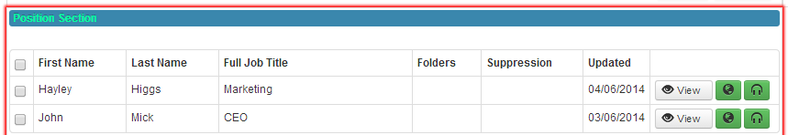

1. Load two records, then for one change any dropdown in Position section e.g. Suppression or Gender. At this point validation for Title suddenly becomes red and displays “The Title entered does not exist. Please select Title pop up and choose the correct title.”

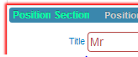

1. Load two records, then for one of the office records Verify (make sure it already has a street address) and at this point validation for field Street Type appear and “The Street Type entered does not exist. Please select Street Type pop up and choose the correct Street Type”



1. Load two records, then for first record which only has Business section, add new Branch and Verify, then add New Office and select ‘Street Type’ and popup fails to load content…

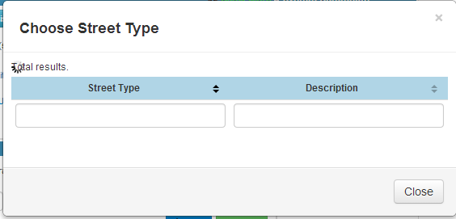

1. Add New Branch, Add New Office, and fill in all details then stays like below forever

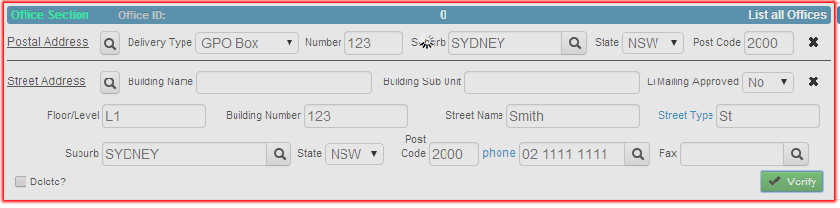

1. I added a new business, branch, office, position and person.

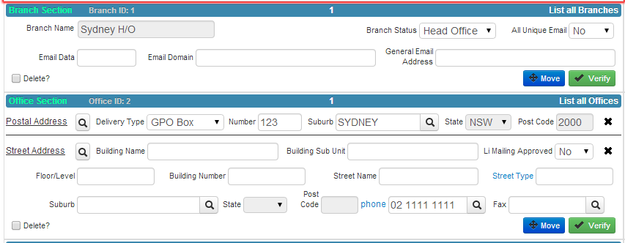

Then when I click List All Branches, it shows ….

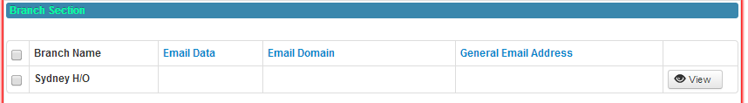

Then when I click View, it shows…

* I didn’t get any issue, after performing above steps. Can you please reconfirm, if you still getting this issue or maybe my above changes would have fixed this?

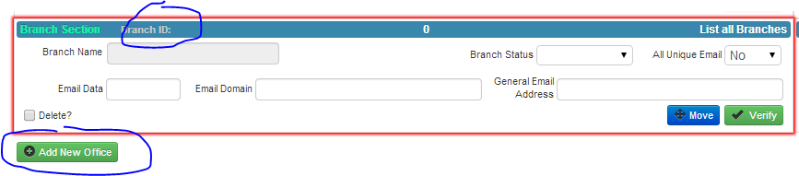

1. There are still lots of issues with Qualify of Street and Postal Address and Validation. To test add a new business, new branch and new office and load one other record. At this point issues will arise. To also test, modify an existing record when one other record is loaded and you will find issues with validation.
2. When I add a new Office and Verify, then when I click on ‘Add New Position’ and then click on ‘List All Positions’, below popup ‘Choose Person’ should disappear…

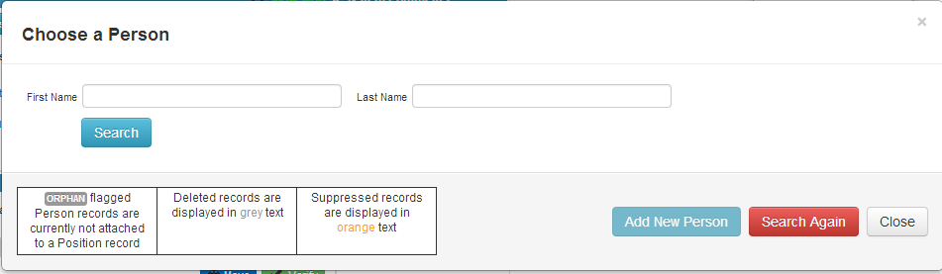

1. There is still strange display issues when load 2 records, add new Position and person…

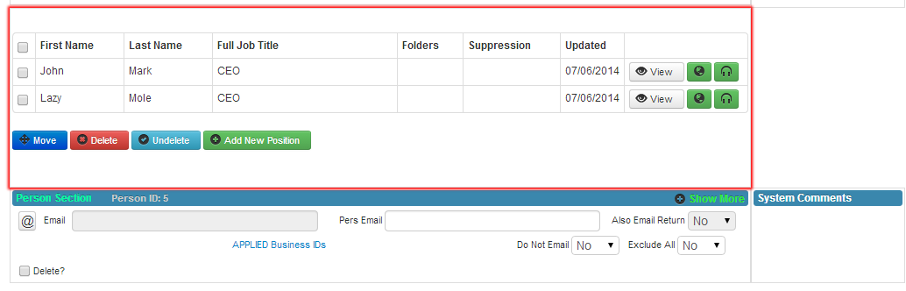

1. When I create a new position and person, when I fill in title, gender and firstname, sometimes after clicking Qualify for First Name there is no green alert message to say its ok.

* Yes, I was totally aware of this issue, I had put it for my later work. Actually the notifications are coming in other loaded OOJ record, to see you can switch different records fast and you will find notifications in any one of them. We are having same issues in almost all the notifications. It would take time, so put it for later work. Let me know, if it’s priority.

1. There are still issues with previous name –first and last name added in popup and searched for reappearing again when I click on ‘Add New Position’. It should be reset to blank and not sure previous name searched on.

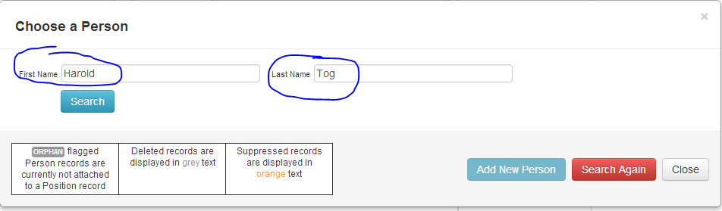

1. Need to make for Attach Person popup column ‘ID’ renamed to ‘Title’ and instead of displaying a ID, display the actual value as appears in 

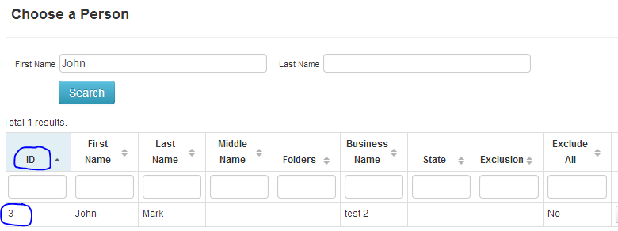

1. When I added a new business record in database, then on front-end I selected ANZSIC codes in popup, when I press OK in popup, it should display this data in below section but it is not…



**Pending:**

1. Are you able to create a popup when data is not saved to database? The dialog can appear as:

"Your update for [insert section name] section was NOT saved to the database. Please notify your supervisor immediately of this error."

This will help me and agents by alerting them of this issue in a more obvious way seeing as this happens more often now and is hard to spot without being alerted to.

1. Need to remove auto scroll up for OOJ records when moving between. Instead the same page point should be kept when clicking different records.
2. Currently for all choose business popups, the Next button doesn’t work. When selecting it, it goes to a different page. To reproduce, just leave filter blank and click on Next.

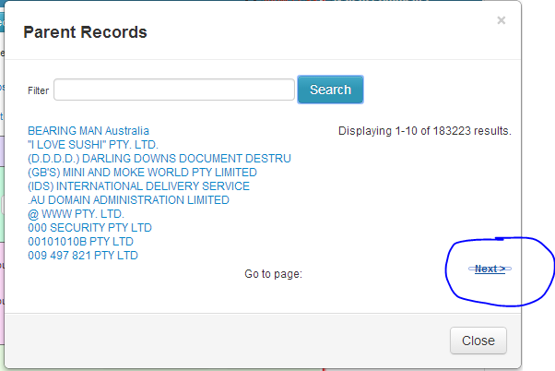

1. When I click on any record and click 'Applied Business IDs' the popup with typeahead does not work.

This is still not working for me. Maybe we can share screen so you can work out issues.

Uncaught TypeError: Cannot read property 'toLowerCase' of null bootstrap.min.js:7

b.matcher bootstrap.min.js:7

(anonymous function) bootstrap.min.js:7

jQuery.extend.grep jquery.js:709

b.process bootstrap.min.js:7

b.lookup bootstrap.min.js:7

b.keyup bootstrap.min.js:7

proxy jquery.js:775

jQuery.event.dispatch jquery.js:3058

elemData.handle.eventHandle jquery.js:2676